Name ____________________

Here are some things to try as you read Fullerenes, Fibonacci Walks, and a Fourier Toy on Math Munch.

- What do you think about the fact that some new 3D shapes were just discovered?

- Here are the graphs of two different fullerenes—one with 20 faces and one with 26 faces.
How many pentagons and hexagons are in each? Don’t forget the BIG one!
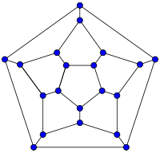
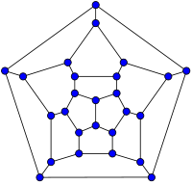

- Here is a Fibonacci word: 0100101001001
Here are two different grids. Try representing the Fibonacci word on each one. There are lots of ways!




- What is the seventh Fibonacci word?

- Find the sum of the digits in each of the first six Fibonacci words. What to do you notice?

- Find out an interesting fact about either Buckminster Fuller, Ptolemy, or Joseph Fourier. Write it below.

- In Lucas’s Fourier toy, the eight numbers at the bottom control how big the revolving circles are.
When you try to change them, don’t forget to push Return!
What is the craziest squiggle you can create with the toy?

- What happens when you use the following number pattern in the Fourier toy?
1 .5 .25 .125 .063 .031 .016 .08
Draw a sketch of what you think would happen if the pattern continued.
What is another number pattern you could try?

