Name ____________________

Here are some things to try as you read Numenko, Turning Square, and Toilet Paper on Math Munch.

- What is this week’s Numenko contest challenge? Use the space below to try to solve it.
Maybe you’ll win a Numenko set!

- Have you played Bloxorz before? If not, go play it right now!

- If you could play a Bloxorz-like game as any 3D shape, which one would you pick? How come?

- This post features the work of three people: Tom Lennett, Jz Pan, and Britney Gallivan.
Which of their projects is your favorite? Why?

- Which would you rather do: create something brand new of your own, take someone else’s idea to a whole new level, or accomplish something that everyone thought was impossible?
Also, can you think of a time when you have done one of these before?

- Think of a math problem that could be inspired by an ordinary roll of toilet paper. Then try to solve it!

- Here are four Numenko puzzles that Justin created. Which of the extra tiles can you fit into the dotted spaces to create true number sentences? Write you answers below each photo.
(Note: The smiley faces are Freechoice tiles—they can acts as any numeral or as a Multichoice tile.)

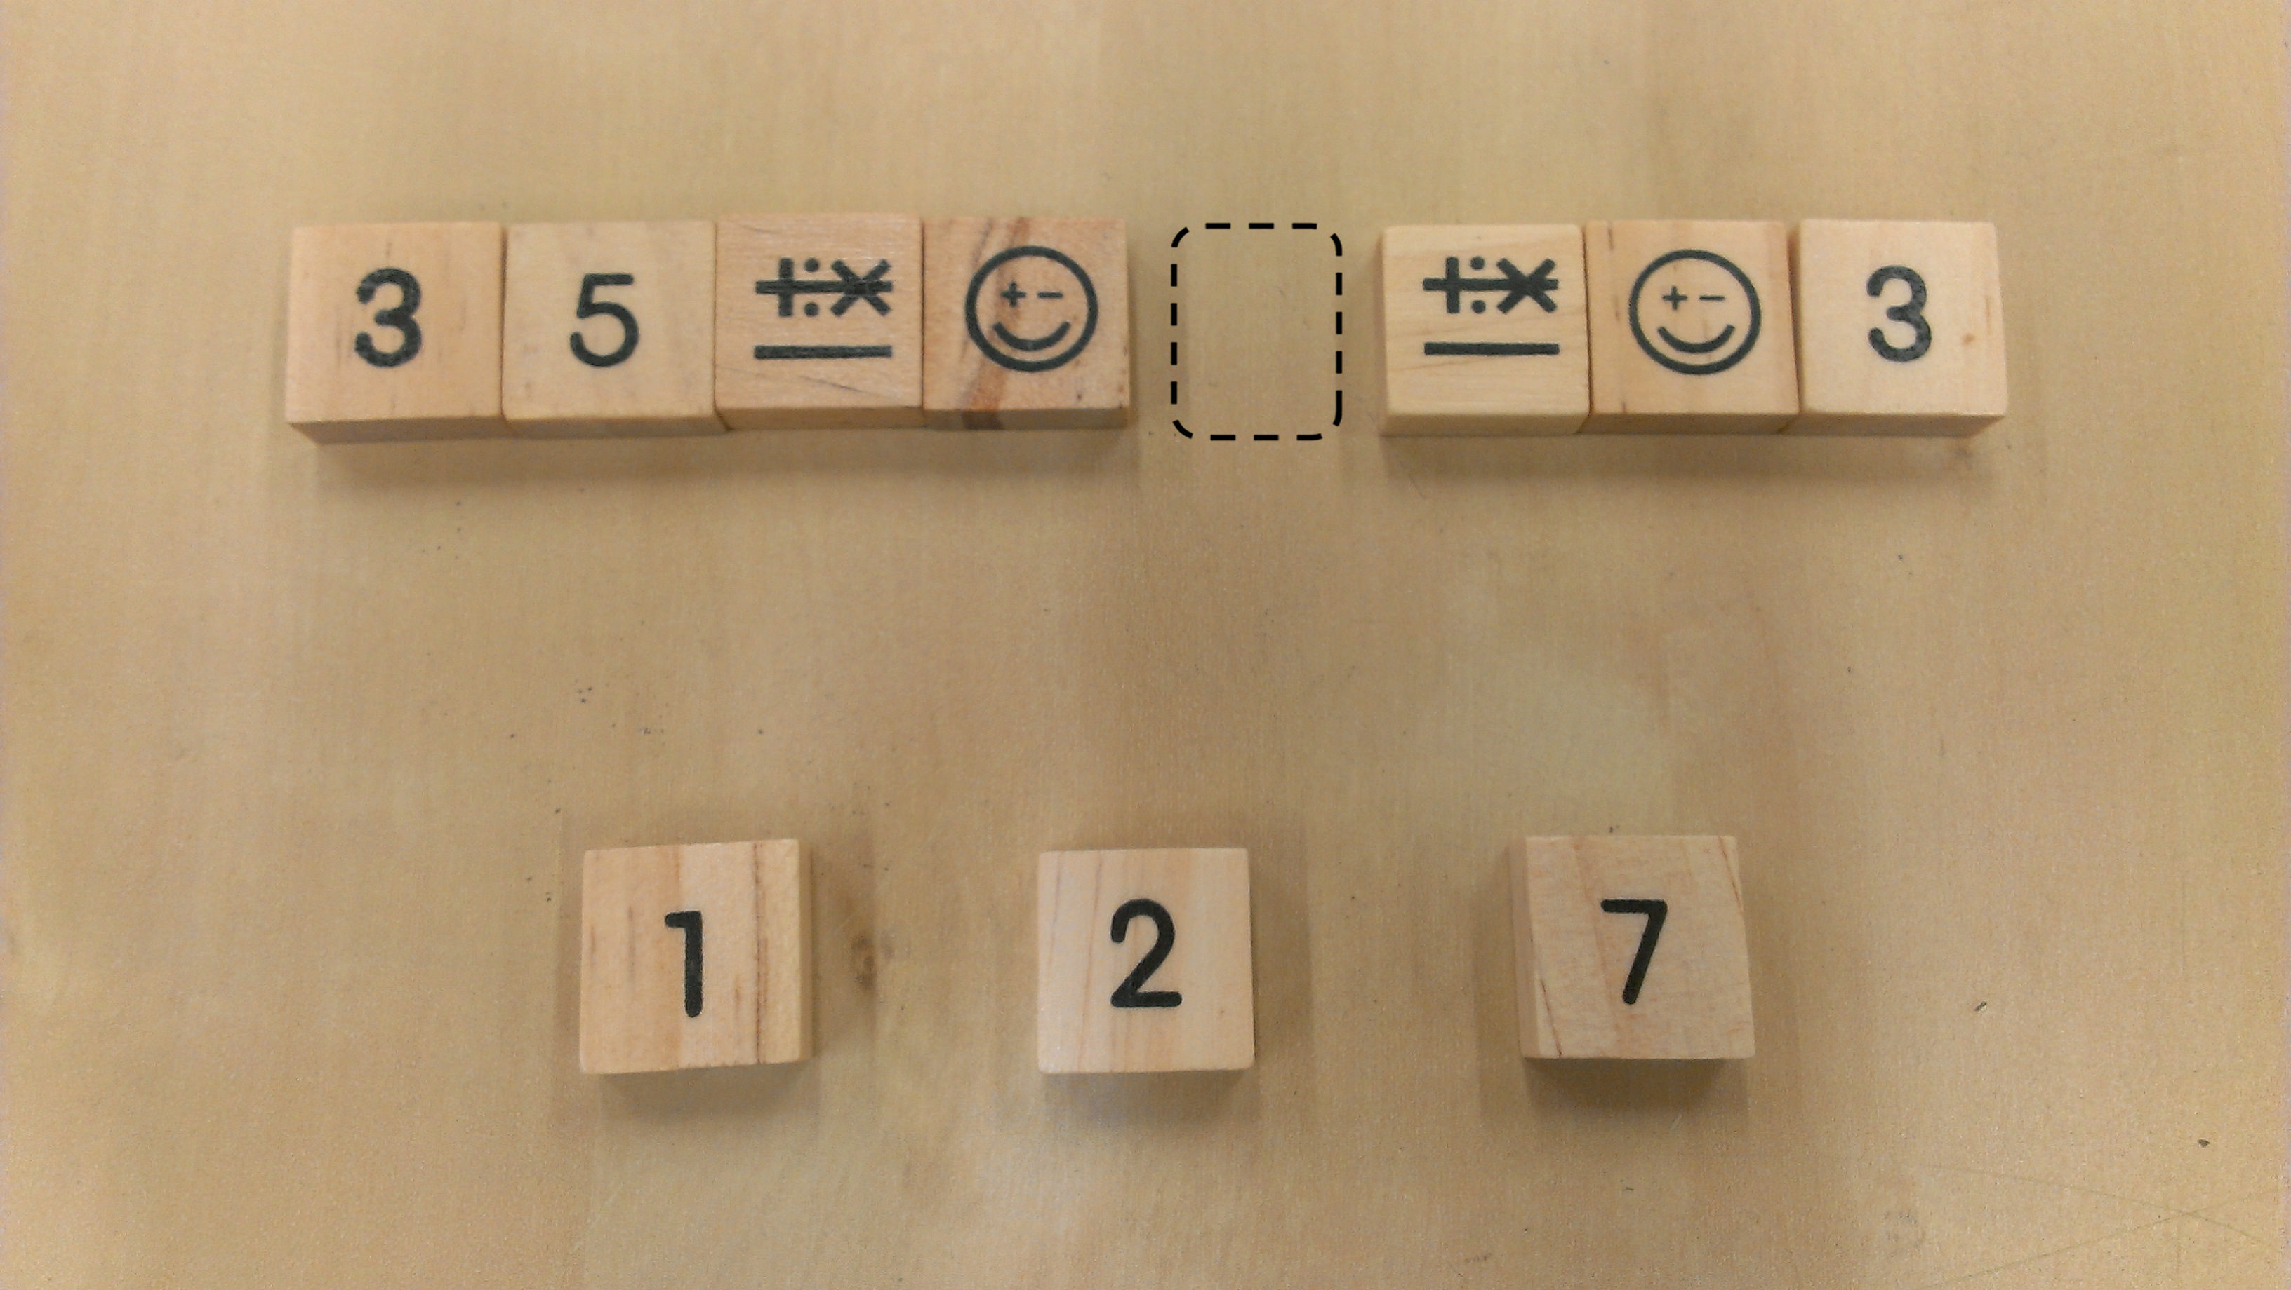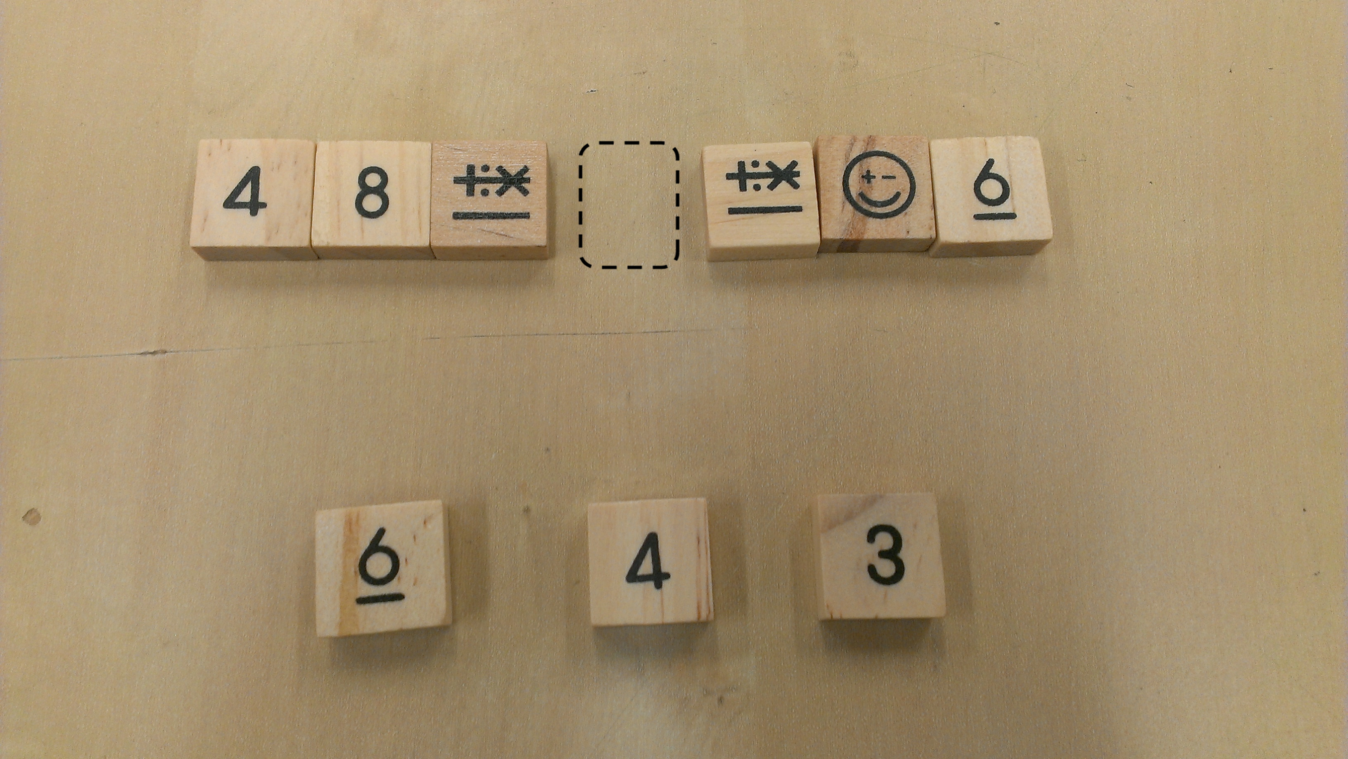

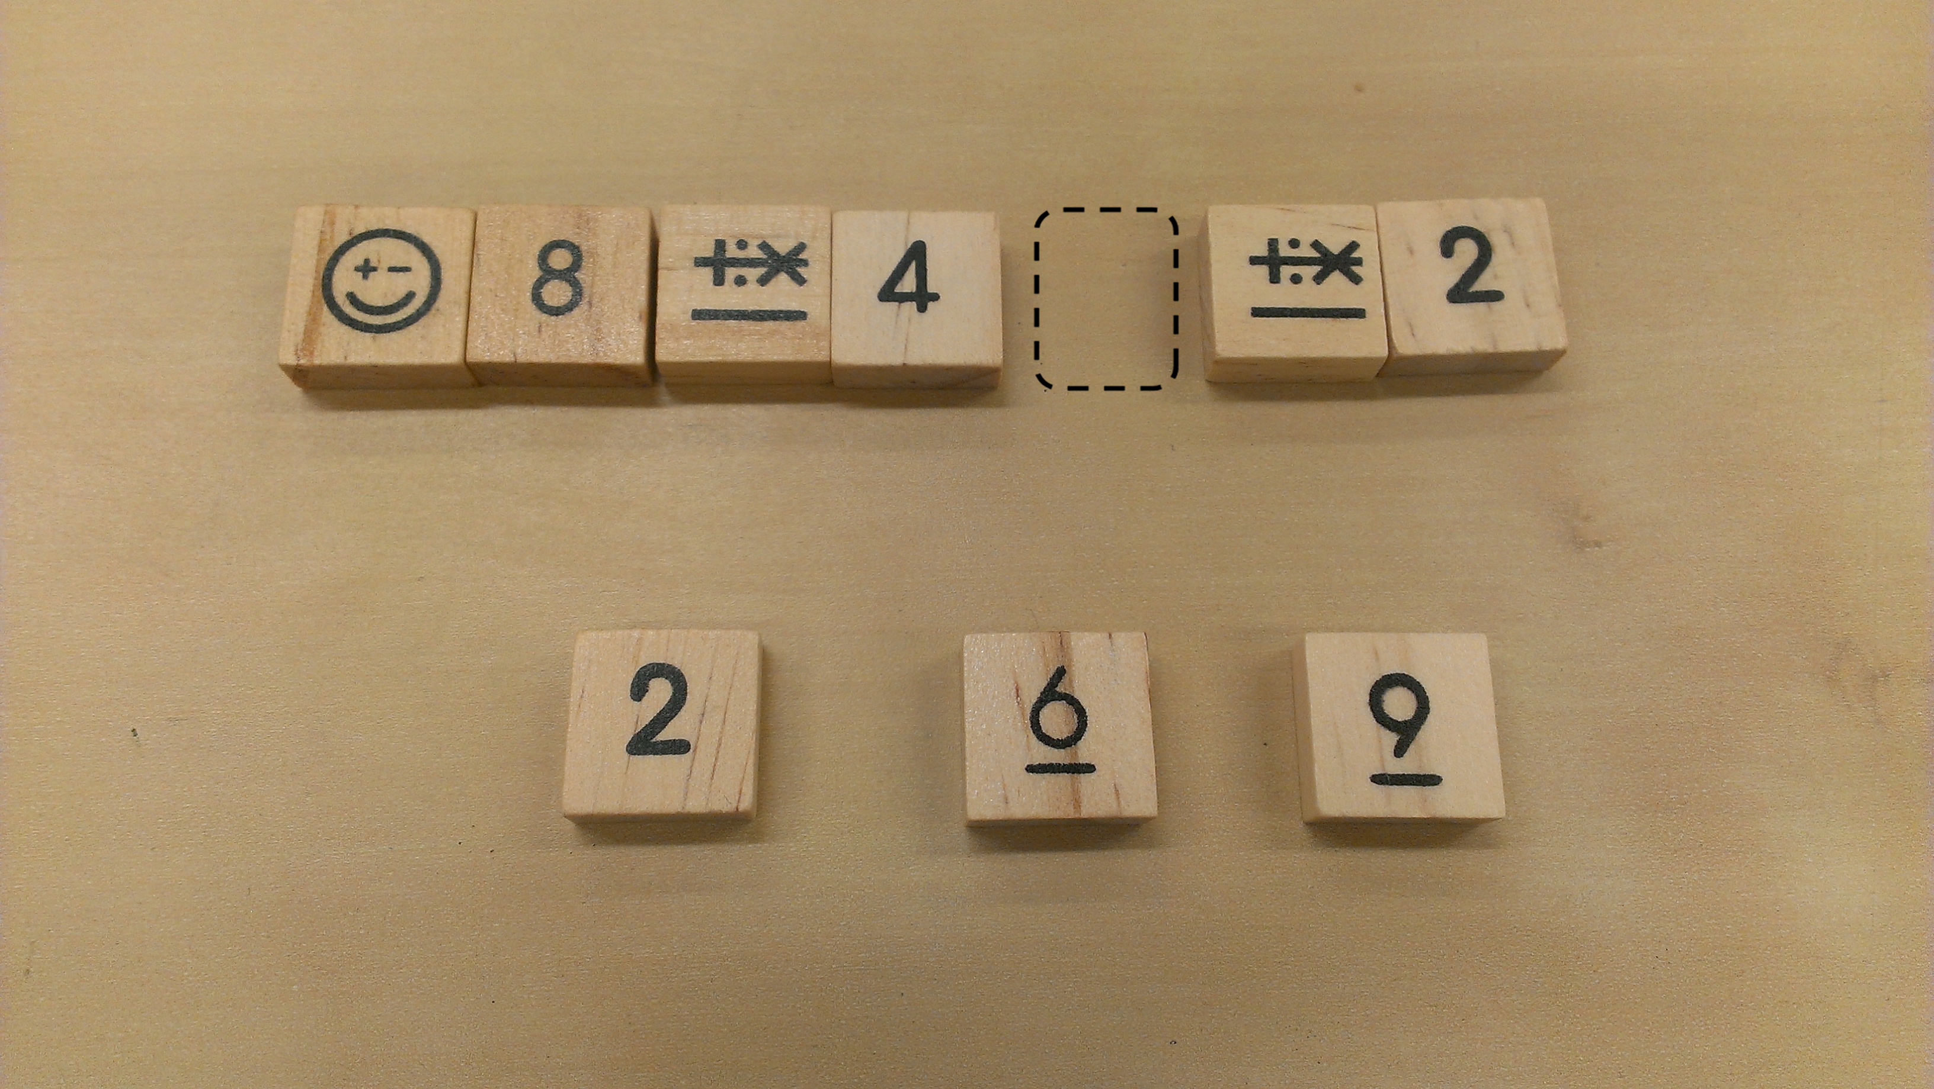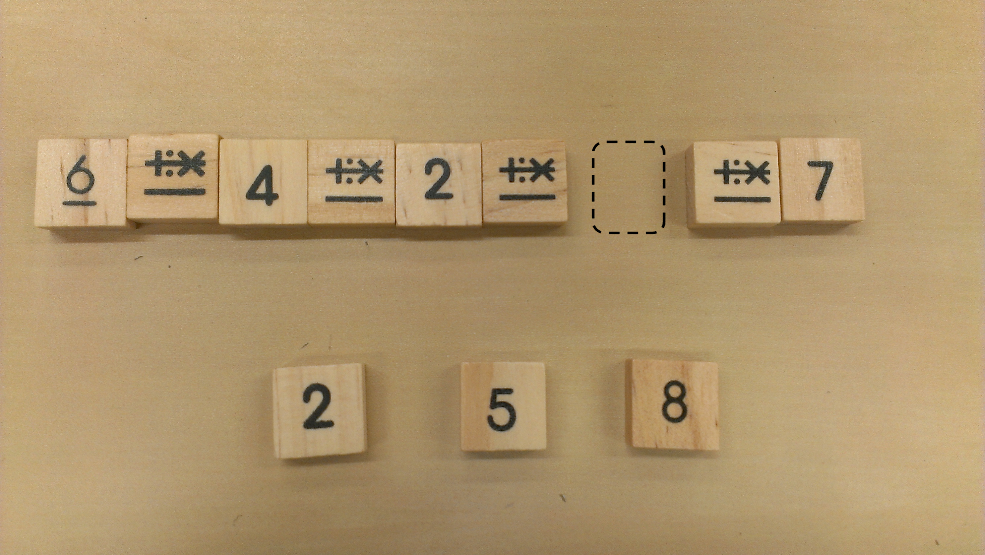

- Now try to create a Numenko puzzle of your own!

