Name ____________________

Here are some things to try as you read Partial Cubes, Open Cubes, and Spidrons on Math Munch.

- Here are some clippings of cubes from Sol LeWitt’s Wall Drawing #601.
What fraction of each cube remains?

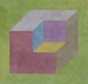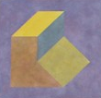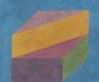

- A cube has six “faces”—a top, a bottom, and four around the sides. All of them are squares.
How many faces do each of the shapes above have?

- Find another piece of artwork by Sol LeWitt that you like. Describe or sketch it below.

- Draw or build a spidron.
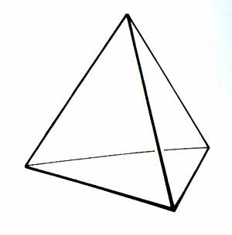

- This is a tetrahedron.

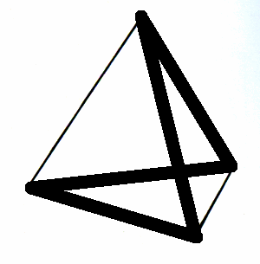
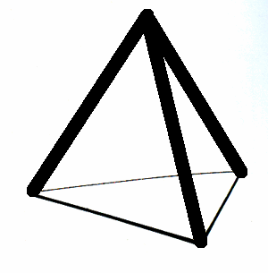
These are the two incomplete open tetrahedra that Justin shared in the post.

What other incomplete open tetrahedra can you find? How many of them are there in all?

