Name ____________________

Here are some things to try as you read SquareRoots, Concave States, and Sea Ice on Math Munch.

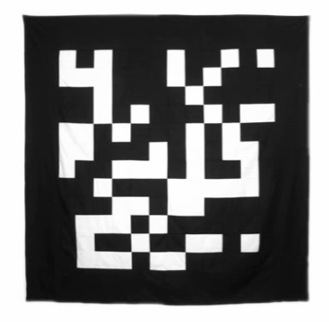
- One of the quilts that John Sims designed is called Black and White Pi. It shows the digits of pi in binary.
In binary, pi begins 11.0010010000111111011010…
Can you spot it in the quilt?
Why does pi start with “11” in binary?

- In your opinion, which of these states is most concave—or “dent-y”?
Can you put them in order from “most concave” to “least concave”?
How did you decide?
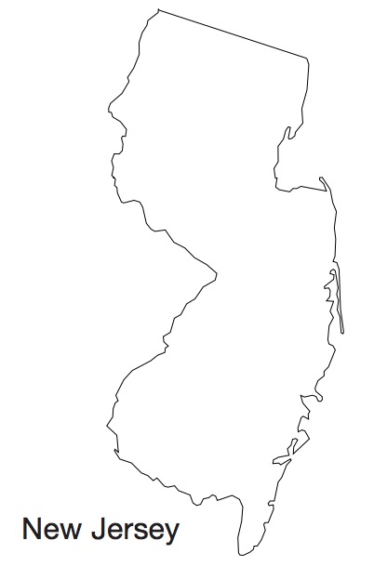
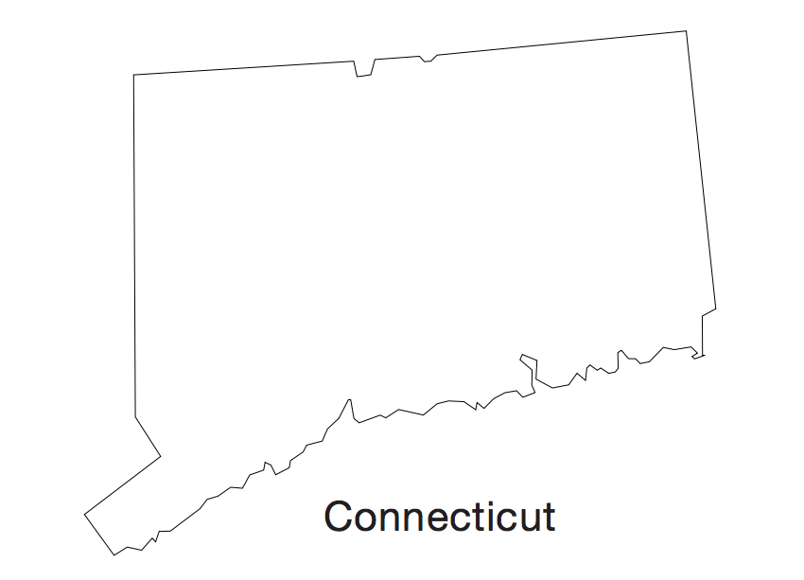
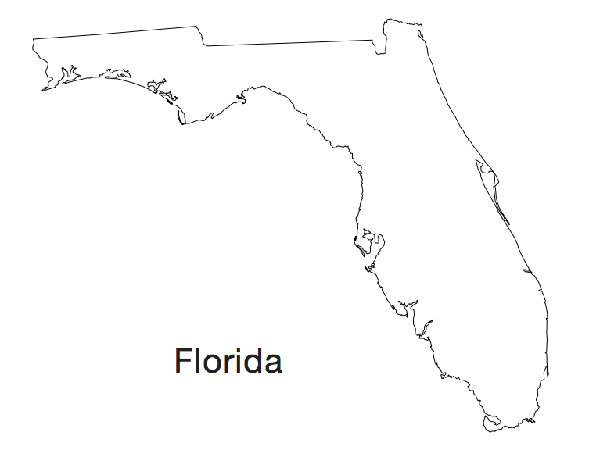
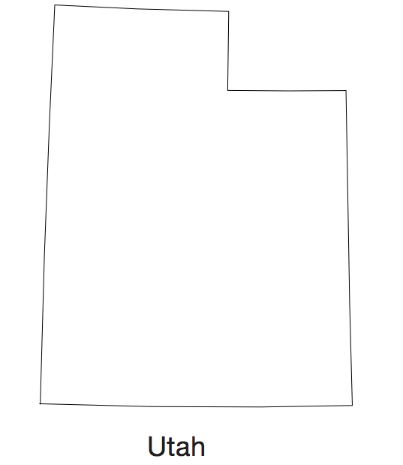

- What question would you like to ask one of the mathematicians featured in the post?

- Last question: what was your favorite part of the post? Why did you like it?

