Name ____________________

Here are some things to try as you read Squircles, Coloring Books, and Snowfakes on Math Munch.

- A squircle is a shape that’s a “combo” of a square and a circle. Choose two shapes, make a “combo” of them, draw it below, and come up with a name for your new shape.

- This is a picture from Marshall’s coloring book. It’s called Gröbner fan #2.
Can you count how many little triangles there are in the picture? Can you count how many total triangles there are? Can you explain why all of the little triangles have the same area?
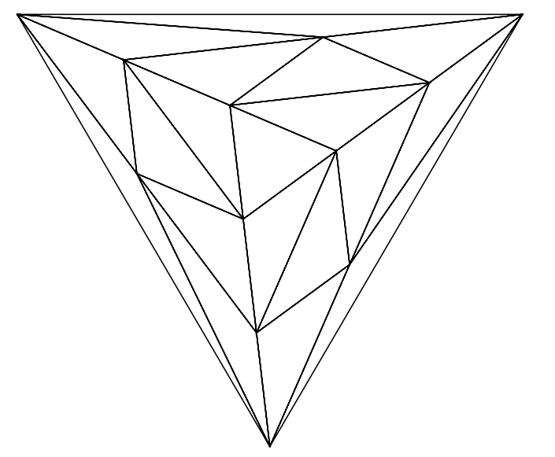

- Print out one of the coloring book sheets and color it in! Or instead try designing a mathematical coloring sheet of your own.

- Which coloring book do you like best: Marshall’s or Alex’s or the one from Patterns for Colouring? How come?

- At the bottom of the post, there’s a link to a Mathematical Imagery page. Pick an image your like from this page. Then on the back of this sheet, try one of the following:
  - draw a copy of the image you picked
  - make a drawing that’s inspired by the image you picked
  - write why you like the image you picked
  - find one new fact about the math that’s in the image you picked and write it down

