Name ____________________

Here are some things to try as you read Tsoro Yematatu, Fano’s Plane, and GIFs on Math Munch.

- Try playing a few game of Tsoro Yematatu using the applet found in the third paragraph of the post. What strategies can you find?

- What country is Tsoro Yematatu is from? Research two interesting facts about this country.

- Can you invent a game that can be played on the Fano plane?

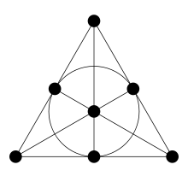

- Choose one of the Bees & Bombs GIFs. Then try to describe it accurately in words, or invent a game inspired by it, or make a flipbook of it, or write a poem inspired by it. Basically, create something!

- In each of the following games of Tsoro Yematatu, you are black and it’s your turn to move. Draw an arrow to show where you would move. The first puzzle is solved for you as an example.

